40.12: 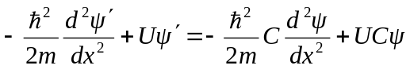
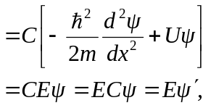
and so 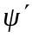 is a solution to 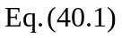 with the same energy.

